Hotel Reservation Form (Yousung Hotel)
(please complete the reservation form and email to Mr Jonghoon Seo (email: sjh9908@hanmail.net, phone: +82-42-820-0613, fax: +82-42-822-0041).
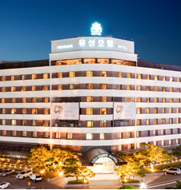 | Address: #480 Bongmyung-dong, Yuseong-gu, Daejon, 305-301, Korea
Tel: +82-42-820-0100/0617
Fax: +82-42-820-4070/0041
E-mail: sjh9908@hanmail.net
Website: http://www.yousunghotel..com

A. Personal Information
□ Mr. □ Ms. □ Prof. □ Dr. □Other | GENDER □ M □ F
First Name: | Last Name:
Arrival (Check-In date): | Departure (Check-Out date):
Address:
City / Country: | E-mail:
Phone: | Passport Number:

B. Hotel Reservation
Room Type | □ Standard Double, □ Standard Twin
Room Rate (KRW) | KRW 111,000 (1 breakfast & spa included)
No. of Room
Special Request of Guest
* Breakfast (buffet) is served at 07:00 ~ 10:30 (additional KRW 10,000).
* All rates are included 10% service charge and 10% VAT.
* Check-in time 14:00 PM, Check-out time is 12:00 noon.

C. Hotel Reservation (Credit Card Information)
□ VISA □ MASTER □ JCB □ OTHER | Card Number:
Expiration Date(MM/YYYY): | Cardholder:
Remark: Your credit card information is for deposit for cancellation or no-show

▶ Cancellation Policy
- 100% Refund : 2 days before your check-in date
- No Refund : 1 days before your check-in date or No-show
Date : __________________________________ Signature :_______________________________

